**Project Initialization and Planning Phase**

|  |  |
| --- | --- |
| Date | 04 JUNE 2024 |
| Team ID | SWTID1720260935 |
| Project Name | Ecommerce Shipping Prediction Using Machine Learning |
| Maximum Marks | 3 Marks |

n

**Define Problem Statements (Customer Problem Statement Template):**

It can be challenging for e-commerce businesses to predict shipment times with enough accuracy so they can properly manage customer expectations. Current approaches sometimes rely on historical data and simplified models, leading to conflicting estimates. The objective is to develop a dependable forecasting model that takes into account variables such as product type, destination, carrier performance, and seasonal demand fluctuations. In order to reduce under- or overestimation, which can have a detrimental impact on customer happiness and retention, and boost delivery window forecast accuracy, this model should leverage machine learning techniques.

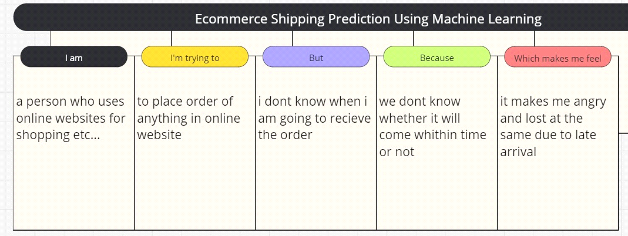

Reference: <https://miro.com/templates/customer-problem-statement/>

|  |  |  |  |  |  |
| --- | --- | --- | --- | --- | --- |
| **Problem**  **Statement (PS)** | **I am**  **(Customer)** | **I’m trying to** | **But** | **Because** | **Which makes me feel** |
| PS-1 | Male customer | To place order of anything in online website | I dont know when i am going to recieve the order | We dont know whether it will come within time or not | It makes me angry and lost at the same due to late arrival |
| PS-2 | female customer | to place a order | i am afraid of online scams that are going around | we dont know whether the product is real fake | it makes me angry and also makes me cry as all my money lost |